Projects proposed at Berkeley Global Campus at Richmond Bay

CEQA QUESTIONNAIRE

SECTION I. PROJECT SUMMARY
Project Title::
Principal Investigator:
Telephone Number:
Email:
Lead Organization
Other Participants
All Locations of Any Project Activities:

SECTION II. BACKGROUND AND INSTRUCTIONS
This questionnaire is intended to facilitate review and approval of research activities at the Berkeley Global Campus at Richmond Bay (BGC).
The BGC is owned by the The Regents of the University of California (UC Regents) and managed by UC Berkeley. A Long Range Development Plan (LRDP) for the site was adopted by The Regents in May, 2014, with an accompanying Environmental Impact Report (EIR). Subsequent activities on the BGC must be undertaken in accordance with the LRDP and EIR mitigation measures. The University is further required to comply with state law regarding environmental review and notice, as may be appropriate. See richmondbaycampus.lbl.gov to view the LRDP and EIR.
The purpose of the CEQA Questionnaire is to provide information on potential environmental impacts a project may pose it order to determine what action the project proponent might need to take to satisfy environmental regulations and the LRDP EIR mitigation measures. Environmental aspects addressed by the EIR include noise, lighting, visual aesthetics, air emissions (chemical and greenhouse gas), stormwater pollution prevention, hazardous materials use and disposal, soils disturbance, traffic, and potential impacts to biological and cultural resources. In particular, all projects at the Former Richmond Field Station Site (RFS) portion of the BGC that involve soil disturbance (including excavation and drilling), must comply with the Soils Management Plan (SMP) provisions of the EIR due to the RFS being managed under a State of California Department of Substances Control Site Investigation and Remediation Order due to legacy industrial chemical contamination. In addition, the RFS contains sensitive native species in the uplands and marsh and projects must provide information necessary to address requirements of the Richmond Bay Campus Coastal Terrace Prairie Management Plan and any Endangered Species Act requirement for work in or near Western Stege Marsh. See the RFS Environmental Website [http://rfs-env.berkeley.edu] for info about site remediation and restoration.
Please note that other aspects of the project such as fire safety, seismic safety, and general campus construction specification are not necessarily included in the analysis of this questionnaire and will be addressed at a later date if the project advances to a Design and Construction phase.

Your answers to the questions in this questionnaire should address the project as a whole, including all work to be performed. In completing this questionnaire, please provide specific information regarding the nature of your proposed action, including information on its size, operations, and the types and quantities of hazardous materials used, air emissions, wastewater discharges, solid wastes, land disturbances , potential increased noise or lighting, potential increases in traffic, etc. Please identify the location(s) of the proposed action, building space and utility requirements, and specifically describe the activities that would occur at that location.
This form may be completed electronically or by hand. In either case, the completed form should be returned via email to scotts@berkeley.edu and tnemeth@berkeley.edu. If additional space is required, please append additional pages to this form.
The form should be completed and signed by the Principal Investigator for a research project, but may be completed and signed by another member of your organization who has sufficient knowledge of the project to answer the questions truthfully and accurately.

SECTION II. PROJECT EVALUATION

1. Below is a chart that asks for four types of identifying information concerning project activities to be performed. Please identify and describe (1) each location where work will be performed, including names of facilities and geographic location (Regatta Property or Former RFS, nearest buildings, see Existing Land Use figure below); (2) the nature of the location (e.g., existing building or hardscape, Research Education and Support Area meadow or grove, Natural Open Space prairie, Western Stege Marsh and marsh ecotone; see Habitat Areas figure below); (3) the types of activities to be conducted at that location; and (4) the scale of each activity, by reference to the following categories:
- Small scale: activities appropriately categorized as “lab” or “bench” scale.
- Pilot scale: activities of a relatively small scale (less than 500 square feet or 10 cubic yards of soil disturbance) and short duration related to proof of concept.
- Large or Other: activities that, by reason of their nature, scope, or duration, do not fall into one of the above two categories.
Question 1.
(1) Location | (2) Nature of Location | (3) Activities to be Performed at each Location | (4) Scale of Each Activity

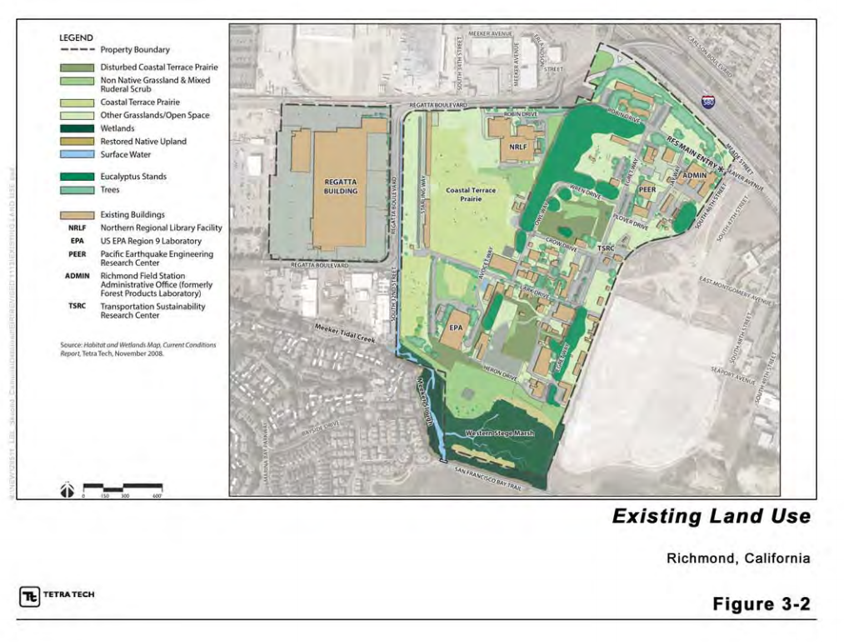

2. In the box below, please identify and provide a brief project overview ( include the following details in your write up) (1) project goals, (2) size (in gross square feet) of the BGC campus area that the project will require, (2) period of time to construct your project, (3) period of time that your project will be active, (4) anticipated plan and person responsible for completion and removal of the project, (4)cost to remove research materials and restore the impacted area to its original condition (if applicable), (5) project funding source.

Explanation:

3. In the box below, please identify and describe (1) any potential health and safety risks to the public or project workers that may result from work under the project, and (2) any efforts that will be taken to mitigate these risks.

Ex: Project will involve the use and handling of various hazardous materials, including metals and industrial solvents. All such handling will occur in-lab, and our organization has dedicated hazardous material disposal practices, so the project activities that involve these materials will pose no risk to the public. Furthermore, all employees have been trained in the proper use, storage, handling, and disposal of these materials, and proper safety equipment is provided. Any potential risks employees face as a result of the hazardous materials are substantially mitigated by this training and equipment.

Explanation:

4. In the box below, please identify and describe (1) any physical modification of existing facilities or construction of new facilities that will occur under the project, and (2) any change in the use, mission, or operation of existing facilities arising out of or resulting from work under the project.

Ex: To accommodate testing facilities necessary for the project, current testing facility will have to be expanded by approximately 4,500 sq/ft.
Ex: A room within our facility that has served as a dedicated wind tunnel will be modified to serve as an environmental test chamber. This will require the adaptation of the chamber’s construction to partition off part of the room and seal it to allow generated environmental fluctuations within.

Explanation:

5. In the box below, please identify and describe (1) all relevant permits, licenses, or authorizations held by each entity performing activities under the project (e.g., environmental permits, operating permits, drilling permits, etc.); (2) any new permits, licenses, or authorizations that will be required to perform work under the project; and (3) any changes to existing permits, licenses, or authorizations required to perform work under the project.
Ex: Project will require a temporary portable 100 HP diesel fueled generator, requiring our organization to secure a Bay Area Air Quality District permit to operate as a source.
Ex: Project includes treatment of microfabrication acid waste through requiring a Conditionally Authorized Hazardous Waste Treatment Permit and approval from the City of Richmond Sewer District for use of the sanitary sewer for treatment effluent.
Explanation:

6. Does the project have the potential to adversely affect any of the following environmentally sensitive resources at the BGC through land use of by introduction of non-locally native flora or fauna? Please indicate below any environmentally sensitive resources that could be adversely affected by any project activities, including plants or animals (vertebrates and invertebrates) anticipated to be introduced.
Historical or cultural resources
Grasslands
Wetlands or waterways
Marshland
Trees or other landscape features

If you checked any boxes above, please provide a detailed description below of (1) the resources that could be affected and (2) how project activities may affect those resources.
Explanation:

7. Is there any uncertainty or scientific controversy concerning the environmental effects of any project activities?
Yes | No

If you checked “Yes,” please describe the nature of the uncertainty or controversy. Please note that uncertainty means that the potential environmental effects are not well known, and controversy means that effects are known but in dispute.
Explanation

8. Would the proposed project utilize, result in, or necessitate the procurement, storage, transport, or disposal of radioactive materials, biohazardous materials, or hazardous chemicals, or ?
Yes | No

If you checked “Yes,” please provide a detailed description of (1) the materials, (2) their role in the project, and (3) procurement, storage, transport, and disposal procedures for each material.
Explanation:

9. Would the project involve the use or development of recombinant DNA or genetically engineered microorganisms, plants, animals, or similar technologies?

Yes | No

If you checked “Yes,” please provide a detailed description of (1) the genetic modifications, (2) the safety procedures in place for their handling and use over the course of the project, and (3) how they will be disposed of at the project’s conclusion.
Explanation:

10. Does the project involve the use, storage, emission, or disposal of any nanoscale materials?

Yes | No

If you answered “Yes,” please describe (1) the nanoscale materials used, (2) potential risks those materials may pose, and (3) how they will be disposed of.

Explanation:

11. Please describe all emissions into the ambient air resulting from project activities. Potential emissions include, but are not limited to, greenhouse gas emissions, particulate matter and airborne pollutants. It is presumed that every project will result in some emissions being released into the ambient air, so applicants answering “none” must explain why no emissions will be released.
Explanation:

12. Would the project result in the release of pollutants or other contaminants into any water resources (e.g., surface water, drainage swales and stormdrains, Western Stege Marsh or ground water)?

Yes | No

If you checked “Yes,” please provide a detailed description of the (1) emissions released and (2) the water resources that may be affected.
Explanation:

13. Please describe (1) any and all solid wastes that will be generated by the project, (2) how they will be handled on site, and (3) the method of their disposal. It is presumed that every project will generate solid wastes, so applicants answering “none” must explain why no waste will be generated.

Explanation:

14. Does the project have the potential to generate a substantial amount of noise pollution, either through construction or during use of equipment during the project implementation?

Yes | No

If you checked “Yes,” please provide a description of (1) the level of noise generated, and (2) the communities that may be impacted.
Explanation:

15. Does the project have the potential to result in any adverse community-based environmental impacts, such as adverse visual impacts or light pollution?

Yes | No

If you checked “Yes,” please provide a description of (1) the communities affected, and (2) what effects the project will have.
Explanation:

16. Will the project create an increase in automobiles use requiring temporary or long term traffic increases and parking needs?

Yes | No

If you checked “Yes,” please provide a description of (1) the communities affected, and (2) what effects the project will have.
Explanation:

17. Please provide a detailed description of the expected duration of the project, and how the project will be decommissioned at its conclusion, including the disposition of equipment and materials. Specify the responsible party for removing equipment and materials at the close of the project….

Explanation:

SECTION IV. CERTIFICATION BY PROPOSER
I hereby certify that I am authorized to submit, and I do so hereby submit, the information in this questionnaire on behalf of the lead organization named below. I certify that the information provided herein is accurate and complete as of the date shown below.
Name
Title
Lead Organization
Signature
Date

SECTION V. PROJECT APPROVAL BY CAMPUS REVIEWERS
Name/Title/Date
Name/Title/Date
Name/Title/Date
Name/Title/Date

Under Federal law, “solid waste” includes any (1) garbage, (2) refuse, (3) sludge from a waste treatment plan, water supply treatment plant, or air pollution control facility, or (4) other discarded material, including solid, liquid, semisolid, or contained gaseous materials resulting from industrial, commercial, mining and agricultural operations. See 42 U.S.C. § 6903(27). Subject to regulatory exemptions and exclusions, “discarded materials” include those materials which are (1) abandoned (i.e., disposed of, incinerated, or stored for later treatment), (2) recycled, or (3) inherently waste-like. See 40 C.F.R. § 261.2(a)(2).

